DEFINITIVE ENTRY FORM COVER
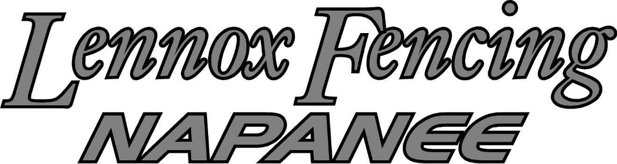
2018 World Barefoot Water Ski Championships
August 11-18, 2018 - Dream Lake, Napanee, ON, Canada

FEDERATION: ___________________________________________

We will be entering the following team and/or individual skiers to the above World Barefoot Championships:

Family Name | First Name | Sex | Jr/Snr/Open | Date of Birth

___________Becky Moynes________________ __________bec.moynes@gmail.com______________ Contact Person Email
Please return this form as soon as possible or prior to the deadline of July 7, 2018, to the following people:
Allan Moynes almoynes@icloud.com
Chairman - LOC LOC Email
Geoff Blaauw geoff@responsere.com
Chairman - WBC WBC Email
Any Federation not meeting this requirement shall not be allowed to compete until they pay a fine of $10 (USD) PER SKIER NOT ENTERED PER DAY to the World Barefoot Council.

Doping control
In accordance with the IWWF Anti-Doping Rules, Doping controls will be conducted during the competition. By entering this competition, all athletes agree to be subject to doping control.
Information about the IWWF Anti-Doping program, the current IWWF AD Rules and links to the list of banned substances can be accessed on iwwfed.com in the "Athletes" drop down menu on the homepage, under the Anti-Doping tab.

DEFINITIVE ENTRY FORM COVER
2018 World Barefoot Water Ski Championships
August 11-18, 2018 - Dream Lake, Napanee, ON, Canada

Family Name | First Name | Sex | Jr/Sr/Open | Date of Birth

DEFINITIVE ENTRY FORM INDIVIDUAL
2018 World Barefoot Water Ski Championships
August 11-18, 2018 - Dream Lake, Napanee, ON, Canada

THIS PAGE MUST BE FILLED OUT FOR EACH SKIER LISTED ON THE COVER FORM

Family Name | First Name | Sex | Date of Birth
 | SLALOM | TRICKS | JUMP
ENTERING AS | JR / SR / Open | JR / SR / Open | JR / SR / Open
Team Member in:
Reserve Team Member in:
Individually Qualified skier in:

Doping control
In accordance with the IWWF Anti-Doping Rules, Doping controls will be conducted during the competition. By entering this competition, all athletes agree to be subject to doping control.
Information about the IWWF Anti-Doping program, the current IWWF AD Rules and links to the list of banned substances can be accessed on iwwfed.com in the "Athletes" drop down menu on the homepage, under the Anti-Doping tab.

