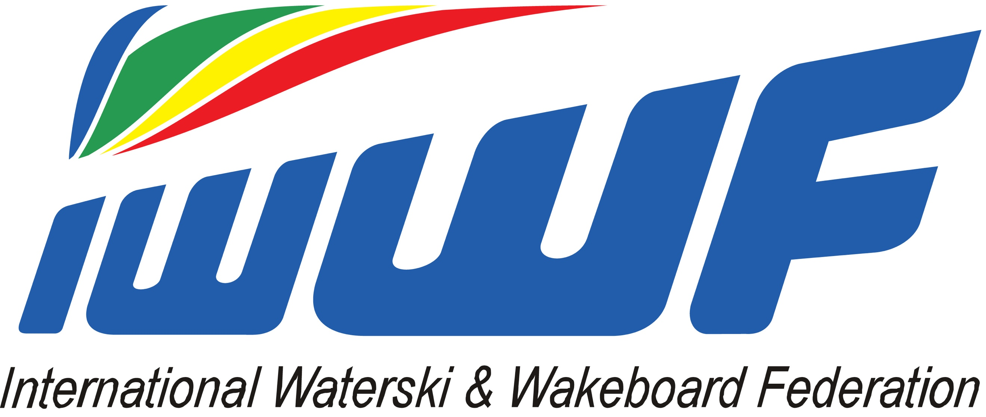

2018 IWWF World Cableski Championships
20 - 23. September – Dnipro, Ukraine

OFFICIAL ENTRY FORM

The ____________________ Federation wishes to enter the following skiers in the 2018
IWWF World Cableski Championships (if not typed, please write in capital letters):

Family Name | First Name | Team skier | Sex  (F/M) | Date of Birth | Slalom | Tricks | Ramp Height
I certify that the information listed above is true and that the registered skier is in possession of a skiing license and valid insurance and relieves the organising Federation, the Officials and the IWWF of any responsibility of any accident which could occur to the skier during the competition and training.

The National Federation confirms that all athletes entered by us into these Championships are aware of, and agree to be bound by, the provisions of the IWWF Anti-Doping Rules, including but not limited to, all amendments to the Anti-Doping Rules and all International Standards incorporated in the Anti-Doping Rules.

Name of Federation Official: ___________________________________

Position in Federation: _____________________________________

Date: _____________________________

Please pay attention to the deadline 05th September 2018 for entries.

Send a copy to the following addresses:

Ukrainian Waterski and Wakeboard Federation ; Maria Bulgakova E-mail: maria.ukrwwf@gmail.com

IWWF World Cableski Council Chairman ; Martin Graw . E-Mail: martin.graw@web.de

